Lab Report 2

ESE – 3014

EMBEDDED SYSTEMS COMMUNICATION PROTOCOLS AND SECURITY

Submitted to :

Linchan Wang

Submitted by:

Gurvinder Singh(748418)

1.Create a 2D plot of the sine function between 0 and 2π.

>>

m = 0:pi/100:2\*pi;

n = sin(m);

plot(m,n)

Inoctave:

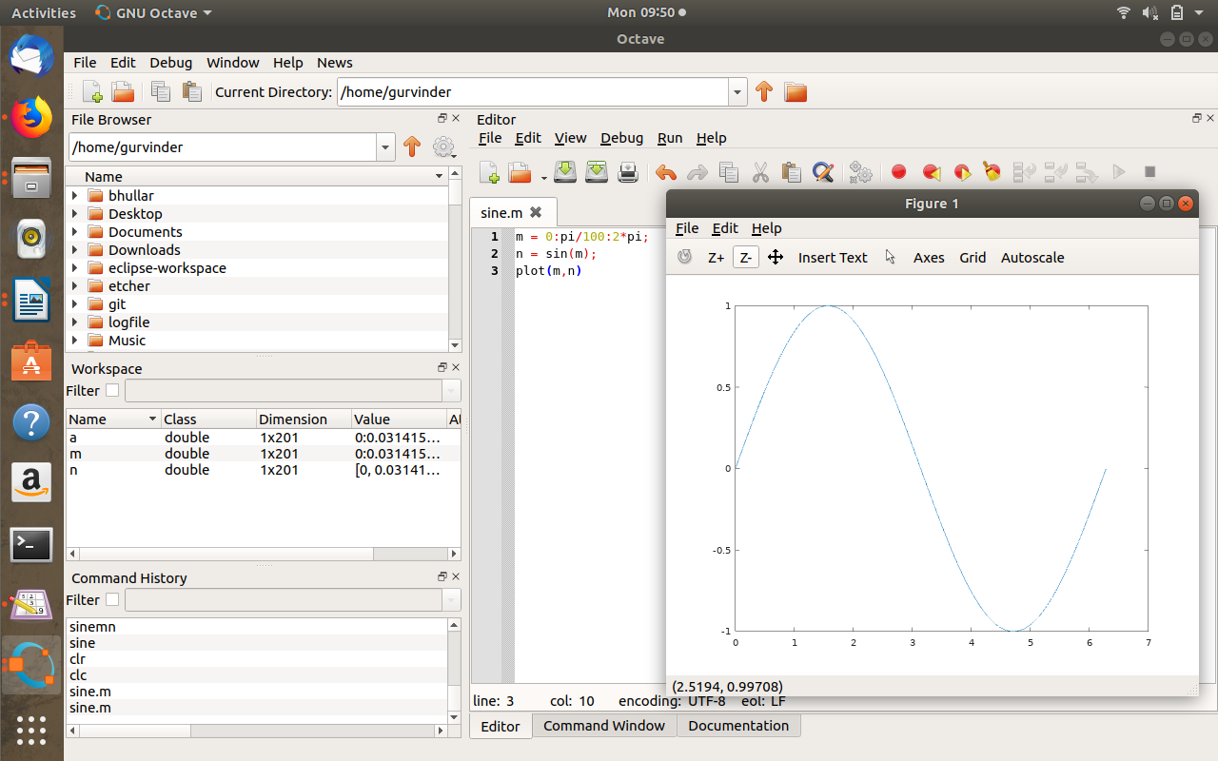

2.Create a 3D plot of a surface by creating a grid along the X and Y axesand plotting the Z-coordinate according to the exponential function.

>>

[M,N] = meshgrid(-5:5:5);

P = M.\*exp(-M.^5 - N.^5);

surf(M,N,P)

In octave

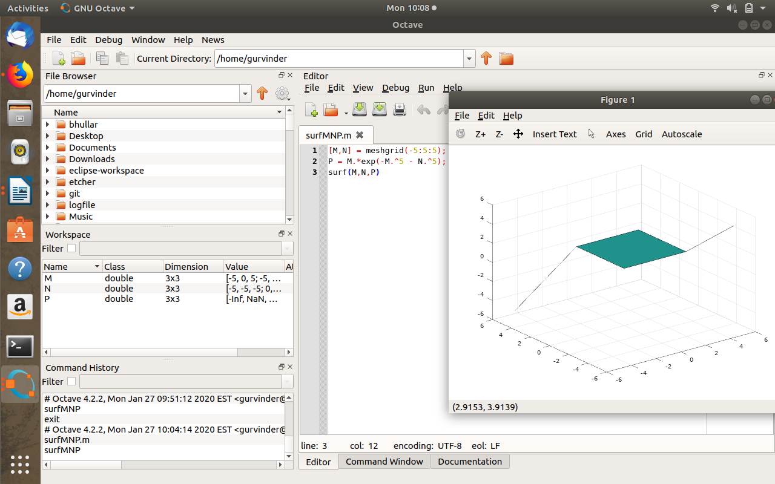

3.Write a script to apply if and if-else statements.

>>

Value = input('Any Value')

if Value < 0

disp('Negative Value')

elseif Value > 0

disp('Positive Value')

else

disp('zero')

end

In octave

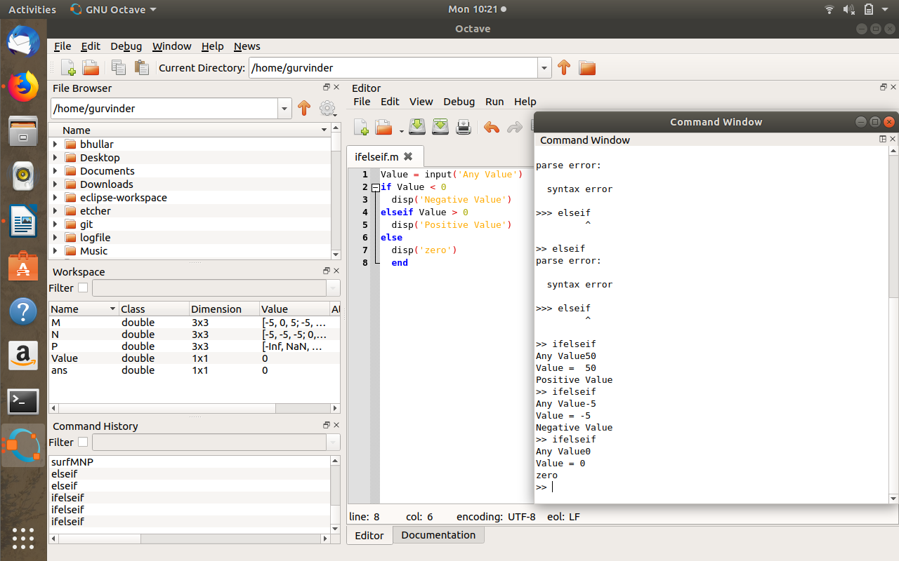

4.Write a script to apply conditional logic switch.

>>

Grade = input("Please enter the Grade = ");

switch (Grade)

case 'A'

disp('Great!');

case 'B'

disp('awesome');

case 'C'

disp('well done');

case 'D'

disp ('Pass');

case 'F'

disp('Fail');

end

In octave

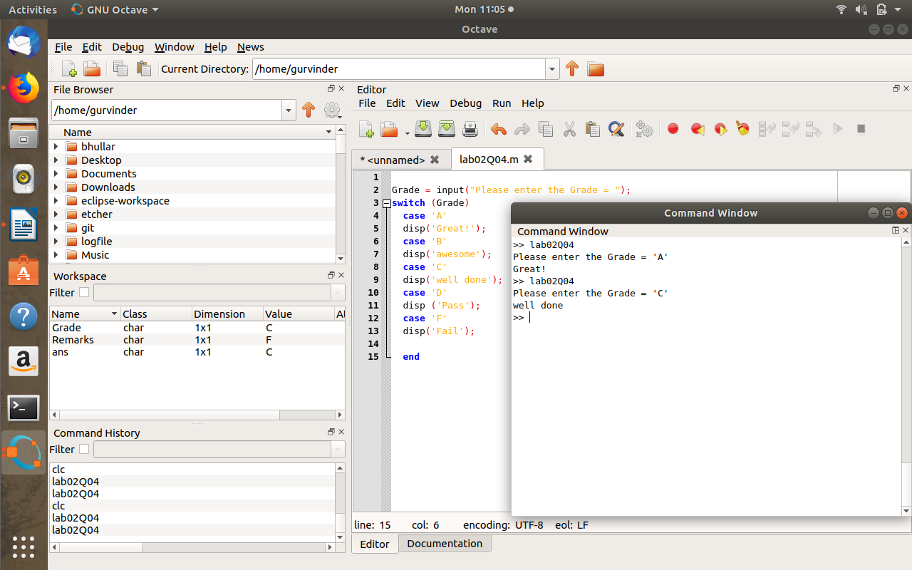

5.Write a script to perform loop with a while condition.

>>

disp(['factorial of n =' num2str(f)])

while M>1

M=M-1;

f=f\*M;

M=12;

f=M;

end

In octave

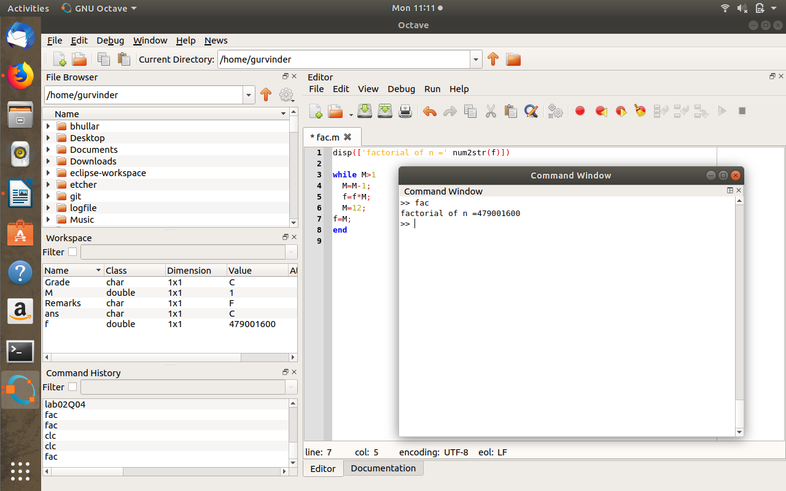

6.Write a script to plot a vector of random data. Draw a horizontal line atthe mean. Save the script and run it from the command line.

>>

x=randi (40,1,30);

y=mean(x);

hold on

plot(x)

plot([0,40],[y,y])

In octave

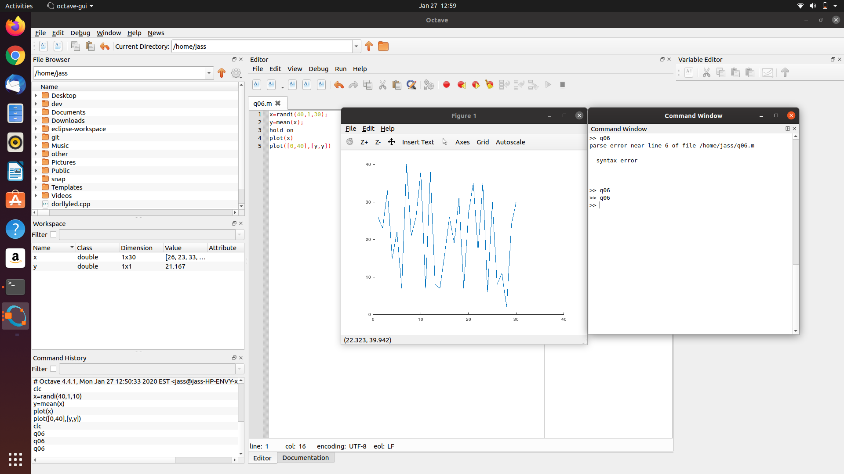

7.Write a script that calculates the mean of five samples of data from avector of random data. Calculate the overall mean. Use a for loop toperform the calculations. For each iteration of the loop print out theintermediate results. Use an if..else control block to display the resultsdepending on whether the mean of the samples is less than, greater thanor equal to the overall mean.

>>

y=0;

x=1;

for n = 1;length(vec)

y=y+vec(n);

disp('intermediate sum of elements');

disp(y);

disp('intermediate mean of the elements');

function m = mean()

disp('Random vector of five value:')

vec = randi(10,5,1)

disp('vector sum is:');

vec1 = sum(vec)

mean = vec1/5;

disp('overall mean value:')

disp(mean);

intermediate=y/x

x=x+1;

if intermediate>6.2000

disp('Note- mean is greater than overall mean')

else

disp('Note-mean is less than overall mean')

endif

endfor

endfunction

In octave

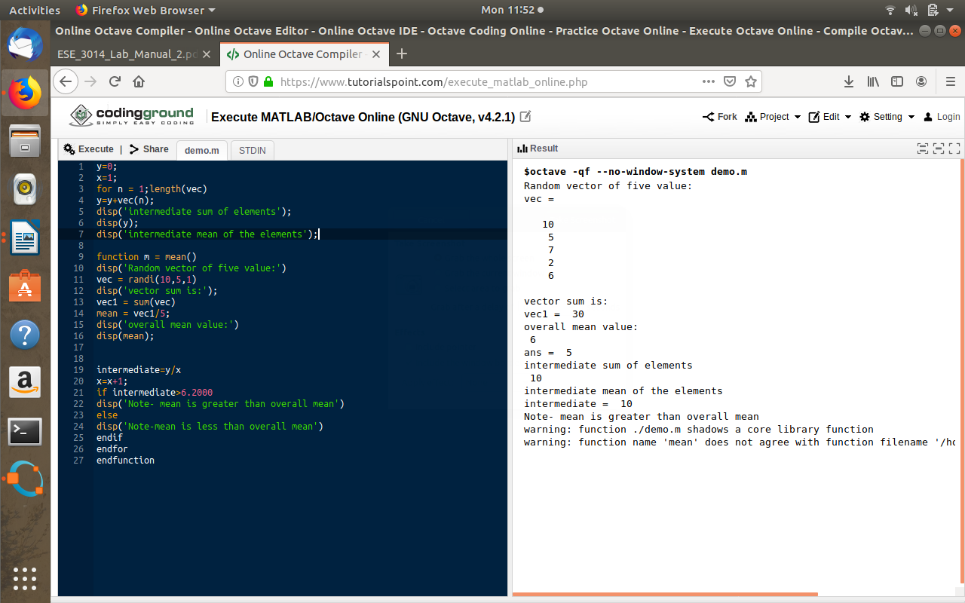

8.Create a function that calculates the area of a circle with the radius as in-put in command window. Call this function from the MATLAB commandline or in a MATLAB script (.m).

>>

function area = areaofcircle(r)

r = input('Enter the radius:');

area = pi\*r\*r;

end

In octave

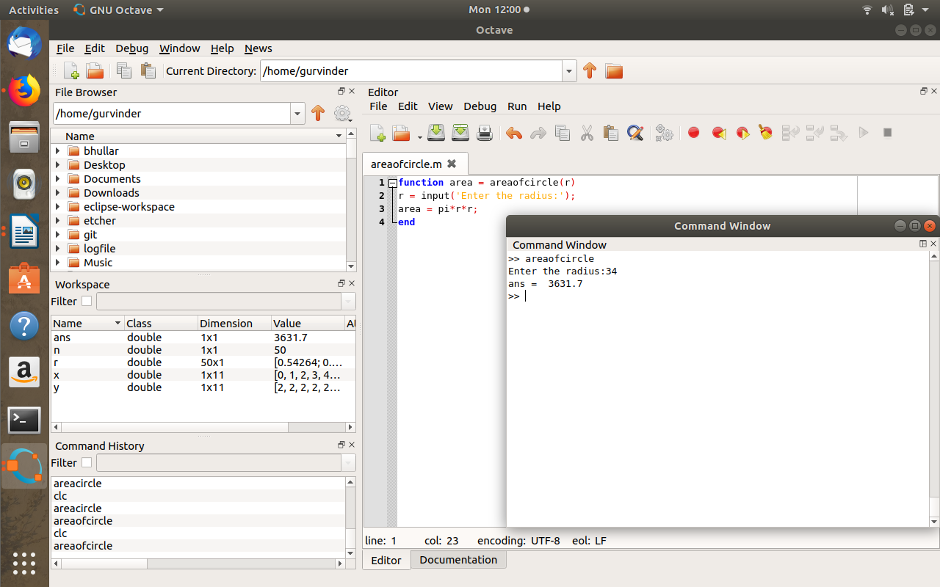

9.Create a function that calculates the sum of an arbitrary number of sinu-soidal terms. Call this function from the MATLAB command line or in aMATLAB script (.m).

>>

function M = SUM[]

M = 10\*sin(40)+30\*sin(60)+50\*sin(80);

end

In octave

